**Market Analysis Report for National Clothing Chain**

Based on current sales information and its relationship with the overall income in the US market, we estimated the income of customers. The estimation model was a linear regression with a strong correlation (R2=0,78) and the resulting formula is as following:

$$Y=0,011x+(-722,142)$$

$$Y→Sales amount | Purchase amount by customer$$

$$x→ Income$$

The estimation gives us as result that the lowest earner has an estimated income of 70k, and the highest earner is a customer in Illinois with a 558k per year. Most of our customers are between the 70k and 100k bucket per year.

On the other hand, when comparing the customer rating and the return rate of the items, we can clearly see, it exists a negative and moderate correlation between the two variables. As expected, the higher the customer rating the lower the return rate of the product.

As per the proposal of offering Bags, Sweaters and Shirts, most of our customers are between the income bucket of 70k and 100k dollars per year, with this purchasing power we recommend the following product offering for the customers.

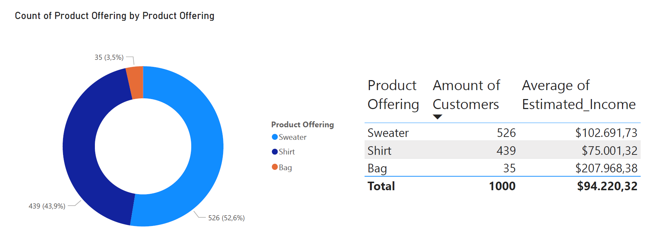

To additional understand the requirement of increase sales, we analyze the historical sales trend, and we classified the customers on two categories. Lost and current customers. A lost customer is one which has not bought any product in the current year. Based on the result, we can affirm there is a strong loss of revenue due to customers that have stopped buying in 2021.